**Learning Objective**

* Understand what CSS means
* Understand Basic Rules of CSS
* Master Basic Units of CSS

**Content**

* Similar to HTML, CSS is not technically a programming language; rather it is a stylesheet language, which in other words allows adding styles selectively to the elements of HTML file.
* The rules of CSS are illustrated below: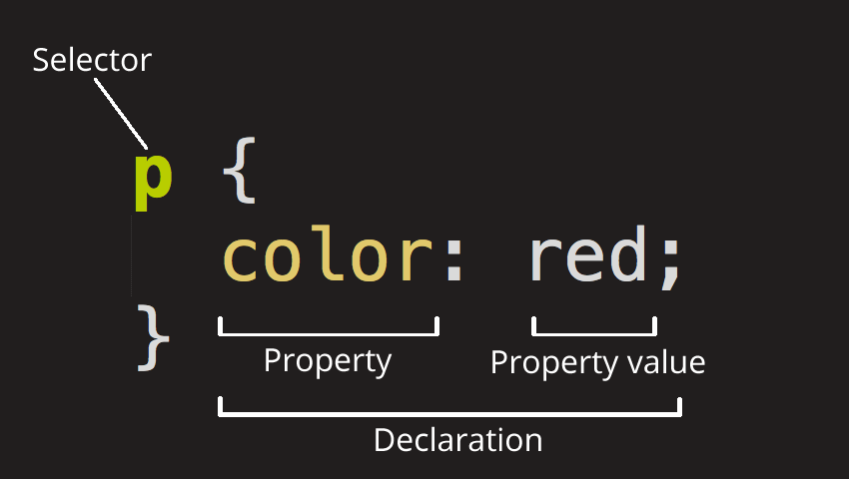
* First the selector is used to specify which elements for adding CSS styles, followed by braces to surround several CSS declarations. Each declaration consists of attributes and values. These CSS styles will be applied together to the elements specified by the selector.
* There are three ways to apply CSS in HTML file, namely:
  + Link: **<link rel="style sheet" href="/path/to/style.css">**

Embed:

* + <style type="text/css">
  + **li {** margin**: 0;** list-style**: none; }**
  + **p {** margin**: 1em 0; }**
  + </style>
  + Inline: **<p style="margin:1em 0">Example Content</p>**
* In CSS, you may add comments by means of /*I am a comment*/, with example below:

*/* set button width*/*

.form **button** {

width: 240px;

}

* Basic Length Unit in CSS
  + Absolute Units:
* px: pixel, corresponding to one pixel of the displayer
* in: inch
  + cm: centimeter
  + mm: millimeter
  + pt: point (1 pt equals to 1/72 inch)
  + pc: 1pc equals to 12pt
  + Relative Unit:
    - em: corresponding to font-size of such element
    - rem: corresponding to font-size of HTML element
    - vh: 1% of browser window height
    - vw: 1% of browser window width
    - vmin: the smaller one between vh and vw
    - vmax: the larger one between vh and vw
  + Colors in CSS
    - Key word, such as: red →red, blue →blue etc.
* Hex, which is represented by three hexadecimal digits, for the value of three colors of rgb from 0 to ff, which represents 0-255, such as: #4286f4
* RGB & RGBA, which stands for red, green and blue, with values ranging from 0-255 respectively, where a represents transparency, such as: rgb(66, 134, 244), rgba(66, 134, 244,0.5),
  + HSL & HSLA, which represents hue, saturation and brightness. Hue refers to the basic attribute of color, which is color name we use daily, such as red and yellow, etc., measured by degrees varying from 0-360. Saturation (S) refers to the purity of color; the higher the amount is, the purer the color becomes. Or the color will gradually gray out if the amount is lower and lower. The higher the brightness, the brighter the color becomes. Saturation and brightness apply the same range from 0% to100%, where a represents transparency with its value from 0 to 1, such as: hsl(120, 100%, 50%)

**Recommendations**

* CSS Basic Grammar (<http://www.w3school.com.cn/css/css_syntax.asp>)
* CSS Basic Knowledge (<https://www.jianshu.com/p/ff608ed0d564>)
* CSSN Basics (<https://developer.mozilla.org/zh-CN/docs/Learn/Getting_started_with_the_web/CSS_basics>)
* 7 CSS Units You Might Not Know About (<https://www.w3cplus.com/css/7-css-units-you-might-not-know-about.html>)